Dining Services Guidelines
Below are procedures you should follow if you work in dining services.
In addition to physical distancing and face coverings, you will see some other changes in the ways that things are done in dining services. In some areas, where close contact with customers is more likely, you will see physical barriers to help prevent prolonged possible exposure to COVID-19
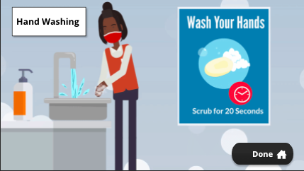

Handwashing
- The CDC recommends 20 seconds of scrubbing to control the risk from coronavirus, a bit more than usual.
- Take the time to wash your hands long enough to protect yourself and others from COVID-19.

______________________________________________________________________________

Serving
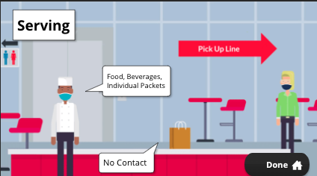
- Self-service is currently restricted, so staff are serving food and beverages. Other foods, such as condiments, are in individual packages.
- Serving practices and other procedures, such as the use of seating areas, will change as re-opening proceeds to other phases. Your manager will be the best source of information regarding future changes.
- If your area will be offering pick-ups, use “no-contact” transfers when meals are being picked up. Bags or food containers should be placed on the counter or table by kitchen/restaurant staff.
- To facilitate physical distancing, call one customer up at a time and allow them to leave the area before calling the next customer.
______________________________________________________________________________

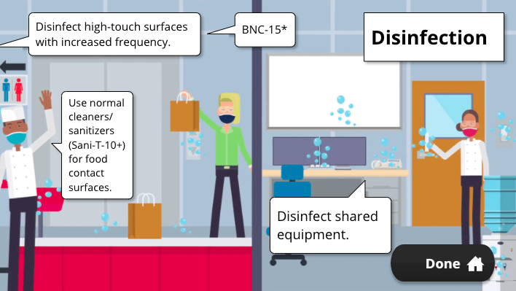
Disinfection
- Increased frequency of disinfecting in employee and customer areas is also required by current guidance. Serving areas; bathrooms; high touch surfaces such as door openers, desks, phones, keyboards, light switches; and other non-food contact surfaces should be disinfected frequently.
- Tables and chair backs in break areas should be wiped down before and after being used.
- Shared equipment and tools, for example step stools, floor machines, dispensers, and janitorial equipment, must also be disinfected after use.
- As we progress to other phases of reopening, frequent disinfection of customer tables and chairs, customer bathrooms, and other high-traffic touch points including but not limited to doorknobs, hand rails, handles, drinking fountains, and elevator buttons, will be required.
- To disinfect surfaces and high-traffic touch points use BNC-15, or other approved disinfectants or wipes. Check the product instructions to make sure the minimum dwell (contact) time is met.
- Avoid using disinfectants on food contact surfaces. Use normal cleaning and sanitizing chemicals (Sani-T-10+) on these surfaces.
- If you do use a disinfectant such as BNC-15 on a food contact surface, clean and sanitize the surface with normal cleaning and sanitizing chemicals before it is used.
- Check sanitizer levels in pot sinks, wiping cloth buckets, and spray bottles, and check dish machine temperatures often to ensure effectiveness.

______________________________________________________________________________

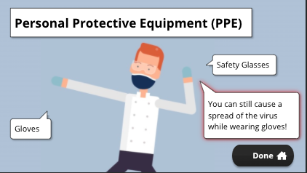
PPE
- PPE use will be based upon the job task and/or the chemical being used. PPE for disinfectant use is determined by the disinfectant manufacturer, so be sure to follow their requirements. At a minimum, gloves and safety glasses will be required.
- Working in food service, you know that contaminated gloves can spread germs. This includes SARS-CoV-2, the virus that causes COVID-19 illness. Be aware of what you touch when wearing gloves.
- Change your gloves and wash your hands when changing tasks, or if you touch something that may be contaminated. As always, handwashing is the best defense against the spread of germs.
____________________________________________________________________________

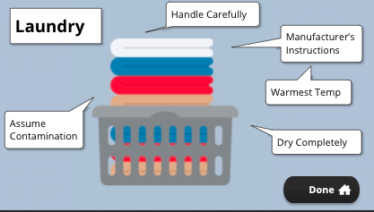
Laundry
- Make sure to take care when handling and do not shake dirty laundry.
- Soiled linen should be handled carefully, with the assumption that it is contaminated.
- Clean items according to the manufacturer’s instructions and use the warmest appropriate water setting.
- Dry items completely.
______________________________________________________________________________

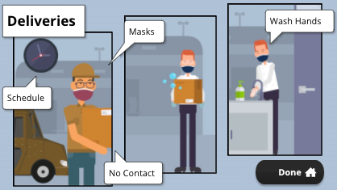
Deliveries
- Delivery personnel and kitchen staff must wear face coverings at all times.
- If possible, delivery staff should schedule specific delivery times, or call ahead to assure kitchen staff are available and no other deliveries are occurring Use a no-contact transfer process.
- Use a transfer process that involves no-contact.
  - Delivery personnel should unload deliveries to a designated area and not enter the kitchen.
  - Kitchen staff should not enter delivery vehicles. When returning to the kitchen, staff must wash their hands.
- If you are delivering food to customers, you will need to use some of the same precautions as mentioned above.

Dining Services Guidelines (cont.)
As you know, everyone on campus will be wearing face coverings and practicing physical distancing as much as possible. When working in food service, it can sometimes be difficult to maintain six feet of physical distance between coworkers and customers, so additional precautions need to be in place to protect everyone.

Wearing masks/face coverings properly is an important first step to cover coughs, sneezes, and the respiratory droplets created by talking, laughing, and even breathing. My mask protects you, and your mask protects me. When wearing a mask, you want to make sure it covers your mouth and nose and fits comfortably but snugly against your face. Wash your hands before and after putting on or taking off your mask. Try to avoid touching or adjusting your mask while wearing it. If you do touch it, treat it as if it is a contaminated surface and wash your hands or change your gloves, the same as you would do if you touched your cell phone.

In addition to physical distancing and face coverings, you will see some other changes to the way things are done in Dining Services. In some areas, where close contact with customers is more likely, like card swipe, cashier, and serving stations, you will see physical barriers to help prevent prolonged possible exposure to COVID-19.

Hand Washing:

Working in UConn Dining Services you already know how to wash your hands,however the CDC recommends 20 seconds of scrubbing to control the risk from coronavirus, a bit more than usual. Take the time to wash your hands for long enough to protect yourself and others from COVID-19.

Serving:
Serving practices have also changed. Customer self-service is currently restricted, so staff are serving food and beverages. Other foods, such as condiments, are in individual packages. Serving practices and other procedures, such as the use of seating areas, will change as re-opening proceeds to other phases. Your manager will be the best source of information regarding future changes. If your area will be offering pick-ups, use “no-contact” transfers when meals are being picked up. Bags or food containers should be placed on the counter or table by kitchen/restaurant staff. To facilitate physical distancing, call one customer up at a time and allow them to leave the pickup area before calling the next customer.

Disinfection:
Increased frequency of disinfecting in employee and customer areas is also required by current guidance. Serving areas; bathrooms; high touch surfaces such as door openers, desks, phones, keyboards, light switches; and other non-food contact surfaces should be disinfected frequently. Tables and chair backs in break areas should be wiped down before and after being used. Shared equipment and tools, for example step stools, floor machines, dispensers, and janitorial equipment, must also be disinfected after use. As we progress to other phases of reopening, frequent disinfection of customer tables and chairs, customer bathrooms, and other high-traffic touch points including but not limited to doorknobs, hand rails, handles, drinking fountains, and elevator buttons, will be required. To disinfect surfaces and high-traffic touch points use BNC-15, or other approved disinfectants or wipes. Check the product instructions to make sure the minimum dwell (contact) time is met.

Avoid using disinfectants on food contact surfaces. Use normal cleaning and sanitizing chemicals (Sani-T-10+) on these surfaces. If you do use a disinfectant such as BNC-15 on a food contact surface, clean and sanitize the surface with normal cleaning and sanitizing chemicals before it is used. Check sanitizer levels in pot sinks, wiping cloth buckets, and spray bottles, and check dish machine temperatures often to ensure effectiveness.

PPE:
Remember to use proper Personal Protective Equipment (PPE) when dispensing and using chemicals. PPE use will be based upon the job task and/or the chemical being used. PPE for disinfectant use is determined by the disinfectant manufacturer, so be sure to follow their requirements. At a minimum, gloves and safety glasses will be required. Working in food service, you know that contaminated gloves can spread germs. This includes SARS-CoV-2, the virus that causes COVID-19 illness. Be aware of what you touch when wearing gloves. Change your gloves and wash your hands when changing tasks, or if you touch something that may be contaminated. As always, handwashing is the best defense against the spread of germs.

Laundry:
If your job involves cleaning dirty laundry, make sure to take care when handling and do not shake dirty laundry. Soiled linen should be handled carefully, with the assumption that it is contaminated. Clean items according to the manufacturer’s instructions and use the warmest appropriate water setting. Dry items completely.

Deliveries:
Take care with deliveries from vendors and internal locations like the Commissary.
- Delivery personnel and kitchen staff must wear face coverings at all times.
- If possible, delivery staff should schedule specific delivery times, or call ahead to assure kitchen staff are available and no other deliveries are occurring.
- Use a transfer process that involves no-contact.
  - Delivery personnel should unload deliveries to a designated area and not enter the kitchen.
  - Kitchen staff should not enter delivery vehicles. When returning to the kitchen, staff must wash their hands.
- If you are delivering food to customers, you will need to use some of the same precautions as mentioned above. Always wear a cloth face covering or mask. Help maintain social distancing, or physical distaincing, by calling to let them know you are on your way or that you have arrived. Unload the boxes or bags containing the meals from the delivery vehicle. The customer should not enter or take their food from the delivery vehicle. Use ‘no-contact’ delivery practices by unloading food onto a clean table, counter, cart, or other surface rather than giving it directly to the customer.

Servicios de comedor
Como saben, todos en el campus usarán revestimientos faciales y practicarán distanciamiento físico tanto como sea posible. Cuando se trabaja en el servicio de alimentos, a veces puede ser difícil mantener seis pies de distancia física entre compañeros de trabajo y clientes, así que deben establecer precauciones adicionales para proteger a todos.

Usar máscaras o cubiertas faciales correctamente es un primer paso importante para cubrir la tos, los estornudos y las gotas respiratorias creadas hablando, riendo e incluso respirando. Mi máscara te protege, y tu máscara me protege. Cuando usas una máscara, quieres asegurarte de que cubra tu boca y nariz y se ajuste pegado, pero cómodamente contra tu cara. Lávese las manos antes y después de ponerse o quitarse la máscara. Trate de evitar tocar o ajustar la máscara mientras la usa. Si lo toca, trátelo como si fuera una superficie contaminada y lávese las manos o cambie los guantes, lo mismo que haría si tocara su teléfono celular.

Además del distanciamiento físico y las cubiertas faciales, verá algunos otros cambios en la forma en que se hacen las cosas en los servicios de comedor. En algunas áreas, donde es más probable que higa contacto cercano con los clientes, como el pase de tarjetas, el cajero y las estaciones de servicio, verá barreras físicas para ayudar a prevenir una posible exposición prolongada al COVID-19.

Lavado de manos:

Trabajando en UConn Dining Services ya sabes cómo lavarte las manos, sin embargo, los CDC recomiendan 20 segundos de lavado para controlar el riesgo de coronavirus, un poco más de lo habitual. Tómese el tiempo para lavarse las manos el tiempo suficiente para protegerse a sí mismo y a los demás de COVID-19.

Sirviendo:

Las prácticas de servicio también han cambiado. El autoservicio del cliente está actualmente restringido, así es que el personal está sirviendo alimentos y bebidas. Otros alimentos, como los condimentos, están en paquetes individuales. Las prácticas de servicio y otros procedimientos, como el uso de zonas de asientos, cambiará a medida que la reapertura avance a otras fases. Su gerente será el mejor informante con respecto a futuros cambios. Si su área ofrecerá recogidas, use transferencia "sin contacto" cuando se recojan las comidas. El personal de la cocina o restaurante debe colocar las bolsas o recipientes de comida en el mostrador o en la mesa. Para facilitar el distanciamiento físico, llame a un cliente a la vez y permítales salir del área de recogida antes de llamar al siguiente cliente.

Desinfección:

Por el guía actual, también se requiere una mayor frecuencia de desinfección en las áreas de empleados y clientes. Áreas de servicio; baños; superficies de alto contacto como abridores de puertas, escritorios, teléfonos, teclados, interruptores de luz; y otras superficies de contacto no alimentarias deben desinfectarse con frecuencia. Las mesas y las espaldas de sillas deben limpiarse antes y después de su uso. Los equipos y herramientas compartidos, por ejemplo, taburetes escalonados, máquinas de suelo, dispensadores y equipos de limpieza, también deben desinfectarse después de su uso. A medida que avancemos a otras fases de reapertura, desinfección frecuente de mesas y sillas de los clientes, baños de clientes y otros puntos de contacto de alto tráfico, incluidos, entre otros, los mangos de puertas, los pasamanos, las fuentes de bebida y los botones del ascensor. Para desinfectar superficies y puntos de contacto de alto tráfico, utilice BNC-15 u otros desinfectantes o toallitas aprobados. Compruebe las instrucciones del producto para asegurarse de que higa cumplido el tiempo mínimo de permanencia (contacto).

Evite el uso de desinfectantes en superficies de contacto con alimentos. Utilice productos químicos normales de limpieza y desinfección (Sani-T-10+) en estas superficies. Si utiliza un desinfectante como BNC-15 en una superficie de contacto con alimentos, limpie y desinfecte la superficie con productos químicos normales de limpieza y desinfección antes de su uso. Compruebe los niveles de desinfectantes en fregaderos, cubos de tela limpia y botellas de rociar, y compruebe las temperaturas de las máquinas de platos a menudo para garantizar la eficacia.

EPP:

Recuerde utilizar el Equipo de Protección Personal (EPP) adecuado al dispensar y usar productos químicos. El uso de EPP se basará en la tarea de trabajo y/o el químico que se usa. El fabricante del desinfectante determina el EPP para el uso de desinfectantes, así que asegúrese de seguir sus requisitos. Como mínimo, se necesitarán guantes y gafas de seguridad. Trabajando en el servicio de alimentos, usted sabe que los guantes contaminados pueden propagar gérmenes. Esto incluye SARS-CoV-2, el virus que causa la enfermedad COVID-19. Ten en cuenta lo que tocas cuando uses guantes. Cámbiate los guantes y lávate las manos al cambiar de tarea, o si tocas algo que pueda estar contaminado. Como siempre, el lavado de manos es la mejor defensa contra la propagación de gérmenes.

Londri:

Si su trabajo incluye limpiar ropa sucia, asegúrese de tener cuidado al tocar, y no sacudir la ropa sucia. La ropa de cama sucia debe tocarse cuidadosamente, suponiendo que está contaminada. Limpie los artículos de acuerdo con las instrucciones del fabricante y utilice el ajuste de agua más caliente y apropiado. Secar completamente los artículos.

Entregas:

Tenga cuidado con las entregas de vendedores y lugares internas como el Comisario.

- El personal de entrega y el personal de cocina deben usar revestimientos faciales en todo momento.
- Si es posible, el personal de entrega debe planear un tiempo de entrega específicos, o llamar con anticipación para asegurar que el personal de la cocina esté disponible y que no haya otras entregas.
- Utilice un proceso de transferencia para que no haya contacto.
  - El personal de entrega debe descargar las entregas a un área designada y no entrar en la cocina.
  - El personal de la cocina no debe entrar en los vehículos de entrega. Al regresar a la cocina, el personal debe lavarse las manos.
- Si va a entregar alimentos a los clientes, tendrá que utilizar algunas de las mismas precauciones que se han mencionado anteriormente. Use siempre cubiertas faciales o una máscara. Ayude a mantener el distanciamiento social, o el distanciamiento físico, llamando a hacerles saber que está en su camino o que ha llegado. Descargue las cajas o bolsas que contienen las comidas del vehículo de entrega. El cliente no debe entrar ni tomar sus alimentos del vehículo de entrega. Utilice prácticas de entrega "sin contacto" descargando alimentos en una mesa limpia, mostrador, carrito u otra superficie en lugar de dárselos directamente al cliente.

